Arbarlith 2 Design Document
This document defines the vision of the game Arbarlith 2 and tries to describe the mechanics of the game in detail.

Project Overview
Title: Arbarlith 2
Dev Path: GCS Small Scale
Estimated Project Complexity: “16-Bit”
Genre: Adventure, Hack’n’Slash
Controls: Keyboard only
Number of Players: Single Player Only
Supported Operating Systems: Microsoft Windows XP

Essence Statement
Fast-paced, hack’n’slash to kill a few minutes at a time.

Game Play
The player’s ultimate goal is to make his way across the world and defeat the final boss. He will face monsters and mini-bosses, puzzles and mazes to impede his progress along the way.

Target Audience
Arbarlith 2 is designed to appeal to the casual gamer or busy, dormant gamer. The target audience is expected to be busy most of the time and will have very little patience for a game without immediate gratification. The player should begin having fun immediately and continuously.

Logo
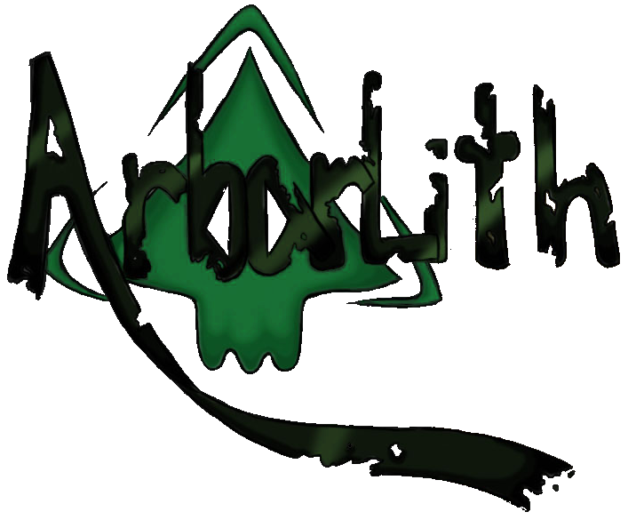

ESRB Rating
Though, obtaining an official ESRB rating is beyond the scope of a project with a $0 budget, Arbarlith 2 will strive for the equivalent of an ESRB “T” rating.

Minimum System Requirements
- Intel Celeron D or M
- 3D Hardware-Accelerated Video Card (i.e. Intel GMA 950)
- 256MB of System Memory
- 50MB Free Hard Disk Space
Inspiration
Arbarlith 2 draws inspiration from many existing games. The following stand out especially:

Secret of Mana
Secret of Mana offers inspiration to the combat system in Arbarlith 2:
- The player may attack quickly, dealing small amounts of damage
- Or the player may wait and attack with one powerful swing

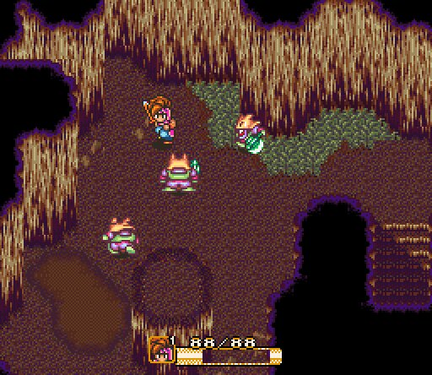

Arbarlith 1
Arbarlith 1, the direct predecessor of Arbarlith 2 offers inspiration to the magic system of Arbarlith 2:
- Spells are obtained through items collected by the player.
- Spells are cast easily and often
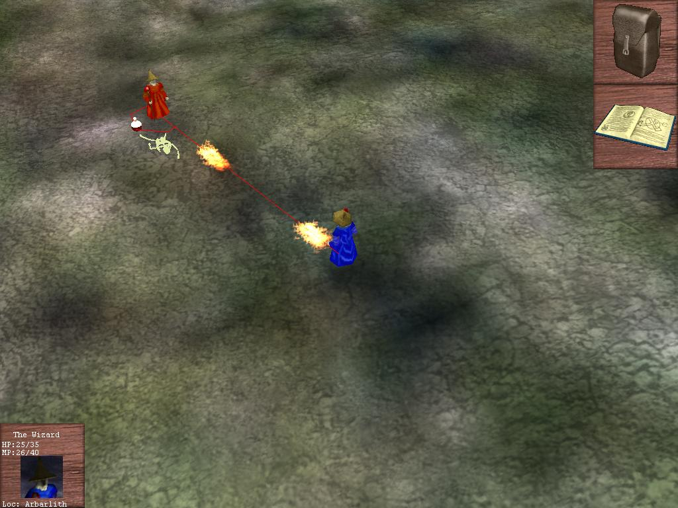

Shotgun Debugger
- Fast-paced action – there is never a dull moment
- Similar pacing as far as placement of power ups and enemies goes

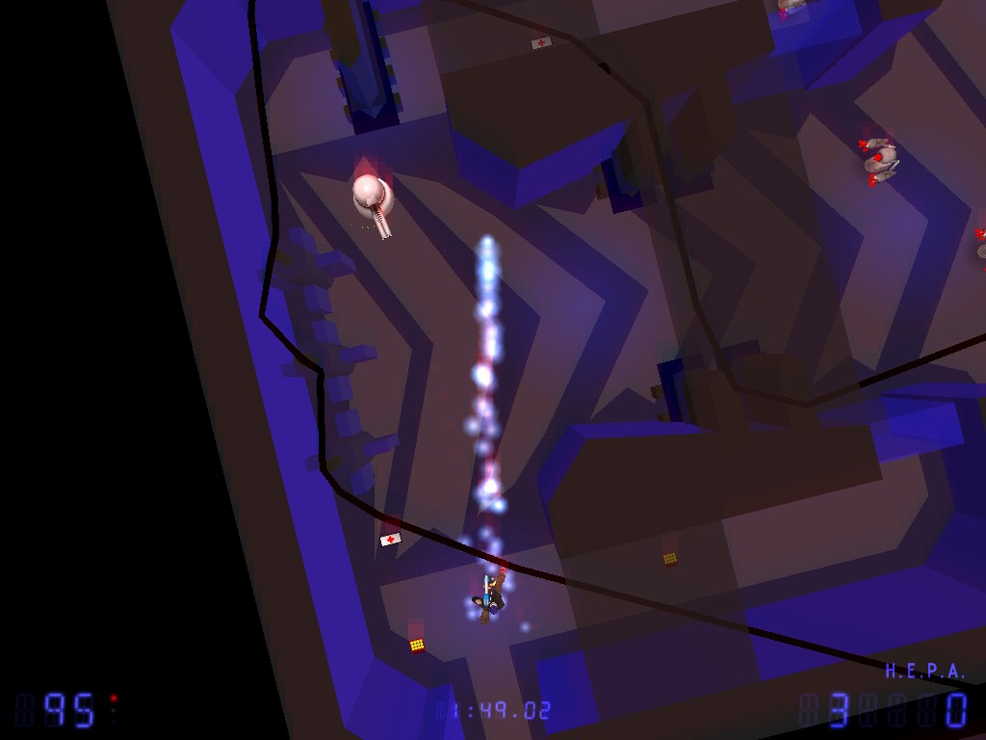

Anticipated Difficulties
- It may be difficult for artists to make the new spell icons match the style of the existing icons.
- The spells must all be hard-coded to avoid the need for a scripting language. This may have its own problems, though.
- Load times may become an issue. If so, we may need to rewrite the save/load portions of the engine to allow for a binary saved-game file format.
- It will be necessary to either find tools to convert 3D models from Arbarlith 1 to MD3 (Quake 3) format, this may cause difficulties.
- Is two weeks enough time for an artist to create the player model?

Project Team Requirements
Min. # | Role | Member Name(s)
1 | Project Leader | Andrew Fox
1 | 2D Artist
1 | 3D Artist
0 | Musician
0 | Sound Effects
1 | Map Design

Schedule
Week | Programmer Progress | Artist Progress | Map Designer Progress
0  2-Feb | (Pitch) | (Pitch) | (Pitch)
1  9-Feb | Combat system finalized.  Monster melee combat AI is finalized. | Existing Monster models have been converted to MD3 (Quake 3) format. | Review the capabilities and limitations of the map format.
2  16-Feb | All monsters are in the editor.  Spell system is complete. |  | Maps are completely designed on paper.
3  23-Feb | Spells are complete  Spell-Caster AI is finalized.  Power-Ups are complete  Power-Up “Items” | Game screen is complete  New character model is complete. | Maps are playable, but no items or creatures are placed.
4  2-Mar | Selection screen is complete.  Bosses are available in the editor | Menu screen is complete
5  9-Mar | Music and sound effects have been procured and are in the game. | World selection screen is completed | Maps are complete
6  16-Mar | Spring Break  For the future:  Controller-Pad  Multiplayer  Story | Spring Break  FEATURE LOCK | Spring Break  FEATURE LOCK
7  23-Mar | Polish and Tweaking |  | Play-Testing and Tweaking
8  30-Mar | PRESENT GAME | PRESENT GAME | PRESENT GAME

Player Character

Old Player Model
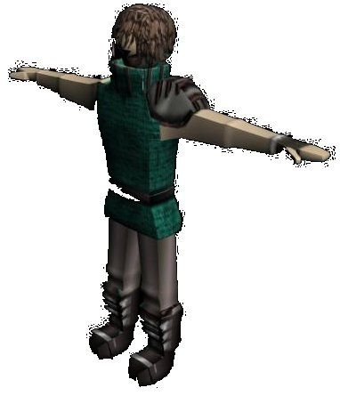
It will be necessary to create a new PC model for Arbarlith 2 to better match the pseudo-anime art style and higher production values of Arbarlith 2.

Concept Art
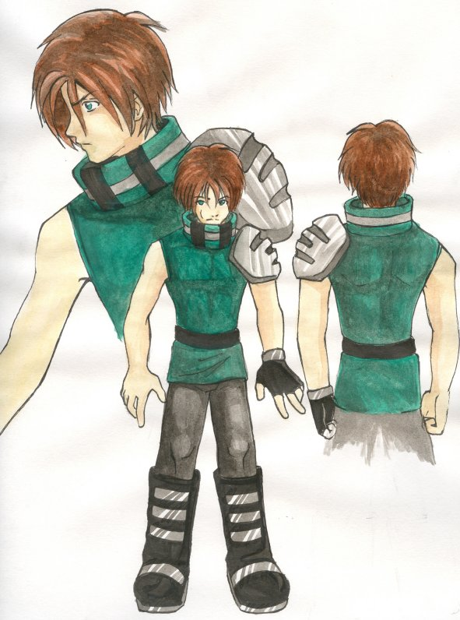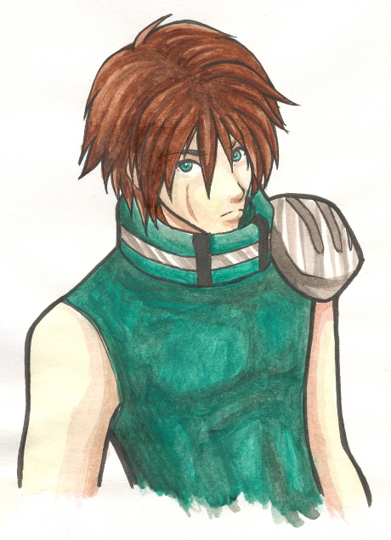

Animations
Run | 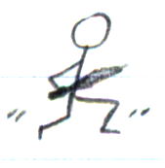 | 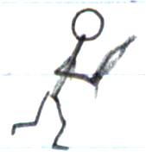 | 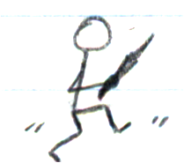
Walk | 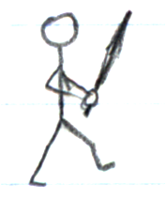 | 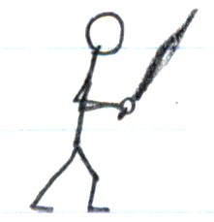 | 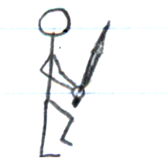
Power Slash | 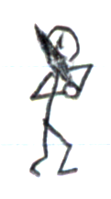 | 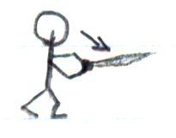 | 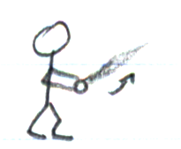
Thrust |  | 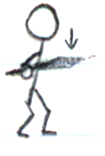 | 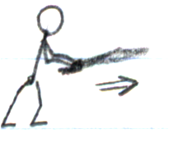
Cast-Spell |  | 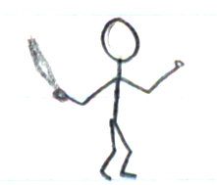 | 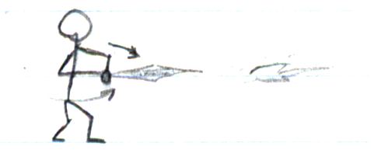
Pain |  | 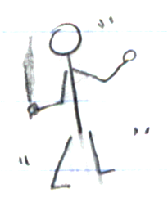
Dying |  | 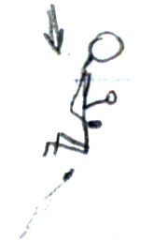 | 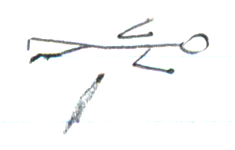

Power-Ups
Power-up items are floating, spinning orbs, often with some object in their center, that affect the PC when touched.
Power-Up Name | Appearance | Effect
Heal | 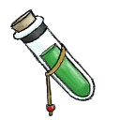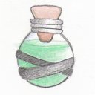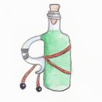 | The PC’s HP will rise over a period of time by some amount. (Similar to the Heal spell)
Double Damage | Dagger (Parasomnia) | For a short period of time, the PC deals double of damage that would normally be dealt.
Defense | 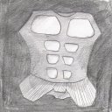 | For a short period of time, the PC receives a portion of damage that would normally be dealt.
Scroll | 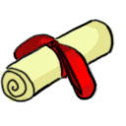 | Adds a spell to the player’s spell book.

Power-Up Assets
Each power up is represented in the game by an MD3 (Quake 3) format model that corresponds with the power up’s function. No new models need be created for these power-ups, they are all reused from Parasomnia and Arbarlith 1.

Worlds
There are 4 worlds in the game. These worlds are presented on the menu similar to the way BRAD or Hatchling Smasher allows players to select a map. Initially, all worlds are locked except the first world. Additional worlds are unlocked as the player defeats the bosses in the previous worlds.
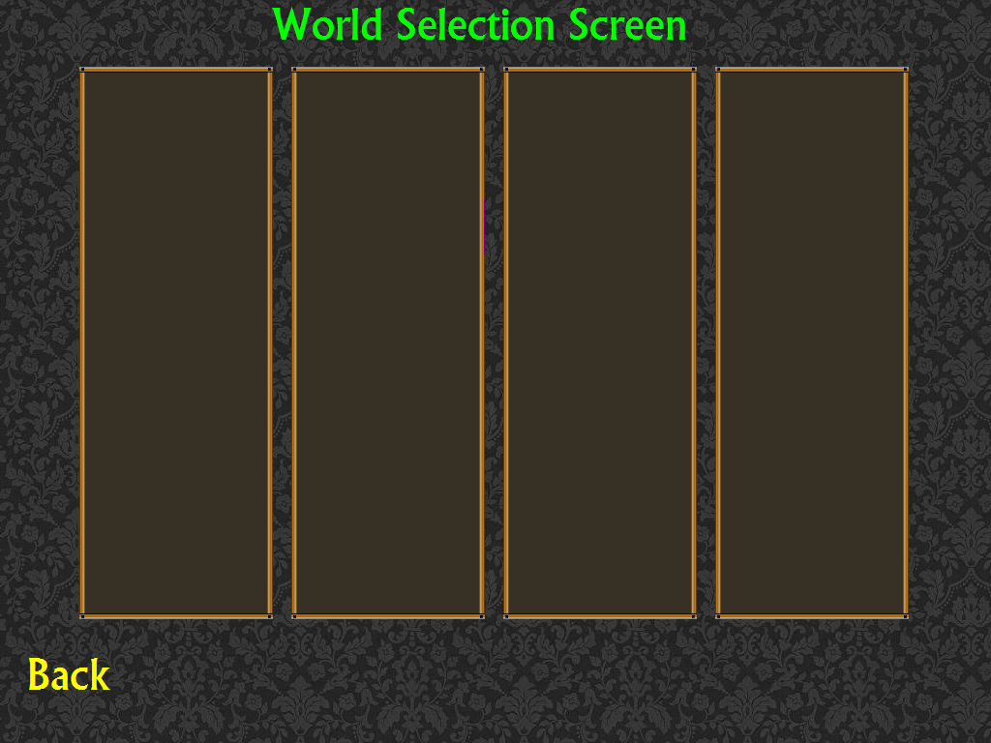

Anticipated Play Time
The Map Design team should be prepared to make each world take about 30 minutes for a player to defeat on the first try. Whether this length is accomplished by making the world physically large, or making it a complex labyrinth, or by filling it with puzzles, or any other method, is left up to the Map Design team.

Construction
Worlds are comprised of a series of rooms, known as Zones, which are connected to each other via a series of door objects. Zones are fixed in size and by themselves, are actually quite small, so a world will need to be made of perhaps a dozen rooms. The rooms themselves may be arranged to give the world the form of a maze or labyrinth, perhaps branching off or doubling back on one another.
Zones should be constructed such that at no point in time can the player see the edge of the Zone or the skybox. It may be necessary to create a large inaccessible region around the border of the Zone to achieve this.

World Selection Screen Assets

Preview image of each world (four 256x512 PNGs)
Template will look something like this:
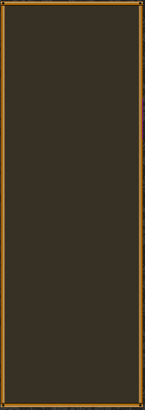

“World is Locked” icon (64x64 PNG with transparency)

“World is Complete” icon (64x64 PNG with transparency)

Props
Props are models that serve mostly an aesthetic purpose, such as a table, chair, or book case.
Arbarlith 2 uses no new props, preferring instead to reuse props from Parasomnia and Arbarlith 1.

Props from Parasomnia
- Table with Table Cloth
- Chair
- Bed

Props from Arbarlith 1
- Wooden Table
- Barrel
- Tree
- Shrub
- Buildings

Creatures

Combat System
First, there are several stats that are necessary for determining the behavior of an attack:
Stat | Description
Attack Damage | Base melee attack damage
Attack Damage Multiplier | Value by which the attack damage of the Creature is multiplied.
Received Damage Multiplier | Value by which the base damage received by a Creature is multiplied.
Attack Cool Down | Minimum amount of time between attacks.
Attack Rate Multiplier | Value by which the base attack rate of the Creature is multiplied.
Attack Charge Time | Affects the damage done by an attack depending on the rate of attack.
Time Elapsed | Time elapsed since the last attack

(Damage Dealt) =
(Target’s Received Damage Multiplier) *
(Attack Damage Multiplier) *
MIN((Time Elapsed)/(Attack Charge Time), 1)

Attack Rate
- Creatures may not attack if (Time Elapsed) < (Attack Cool Down).
- Time elapsed is reset to zero when an attack occurs

Power Bar
- A Blue Power Bar* on the GUI will display MIN((Time Elapsed)/(Attack Charge Time), 1)
- When the Power Bar reaches 100%, it will begin to flash brightly
* Reuse the “Mana Bar” graphic from Arbarlith 1

Stats
See the combat section for stats related to combat. Monsters, Bosses, and the Player do share several other stats, though:
Stat | Description
HP | Health Points. When HP <=0 a Creature is said to be dead.
Movement Speed | Meters per second
Movement Speed multiplier | Value by which the speed of the Creature is multiplied.
Spell recovery multiplier | Value by which the base recovery time of a spell is multiplied.

Melee AI
The monster walks around randomly until the player gets close to it. Then, the monster moves closer so that it can attack the player. This monster will not flee from the player and will continue its pursuit for as long as the player is within a few meters of the monster. If the player attacks the monster preemptively, then it will immediately notice the player and begin to retaliate.

Spell-Caster AI
If at all possible, the spell caster will buff nearby monsters. The monster walks around randomly until the player is in its line of sight. Then, it moves closer so that it can begin to cast spells to attack the player. If the player gets too close, the spell caster will flee to a safe distance. If the player attacks the monster preemptively and the player is not close to the monster, then it will immediately notice the player and begin to retaliate. If the player attacks the monster preemptively and the player is close to the monster, then it will immediately notice the player and begin to flee.

Bosses
Bosses use the models of regular monsters, though they tend to be much larger in size. A boss will also tend to be much tougher than the regular version of the monster. Boss AI will make use of patterns of attack and movement much like an old arcade game; it is to the player’s advantage to learn and exploit this patterned behavior.
One room in each World should contain a Boss, defeating this boss will cause the player to be returned to the World Selection Screen, the World to be marked as completed, and the next World to be unlocked.

Monster Assets
Monster assets will be reused from previous games as much as possible.
Name | Source
Theodore | Reused from Parasomnia
Matilda | Reused from Parasomnia
Otis | Reused from Parasomnia
Chaos | Reused from Arbarlith 1
Spider | Reused from Arbarlith 1
Skeleton | Reused from Arbarlith 1
Wizard | Reused from Arbarlith 1

Monster Files
Each monster has assets as follows:
data/objects/{monster-name}.xml
data/{monster-name}/model.xml
data/{monster-name}/model.md3
data/{monster-name}/skin.jpg

Spells
Magical actions are called Spells, there are several varieties. Spells, once cast, require some time, varying depending on the spell, to recover. During the recovery period, no other spell may be cast. The spell-caster will flash to indicate that the recovery period is in progress.

Attack Spells
Spell | Description
Fire Ball | Launch a fire projectile.
Incinerate | The player is engulfed in a large explosion. Nearby enemies are damaged.
Ice Blast | Launch an ice projectile
Ice Wave | Launch ice projectiles radially outward from the player
Chill | Freezes nearby enemies for a time

Buffs
Buffs may target a particular creature. The player may only target himself and does not have access to Buff Spells that can harm the caster in this way.
Spell | Description
Heal | Target’s HP increases over the next few seconds
Full Heal | Target’s HP is immediately set to full
Poison | Target’s HP decreases over the next few seconds
Nullify | Removes all buffs and status effects from target
Buff Armor | Target’s Defense Multiplier is set to a high value for a time
Break Armor | Target’s Defense Multiplier is set to a low value for a time
Buff Weapon | Target’s Attack Multiplier is set to a high value for a time
Break Weapon | Target’s Attack Multiplier is set to a low value for a time
Slow | Target’s Speed Multiplier is set to a low value for a time
Haste | Target’s Speed Multiplier is set to a high value for a time

Spell Icon Assets
Each spell requires two small images (Spell Icons) to represent the spell on the circular menu and while that spell is being cast
- Selected Spell (80x80 PNG) – Bright, with a parchment-like background
- Unselected Spell (80x80 PNG) – Dull, washed out, with a parchment-like background
Several spells icons will be reused from Abarlith 1. These are included for reference:
Ice Wave | Ice Blast | Chill | Heal | Fire Ball | Incinerate
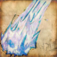 | 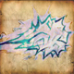 | 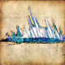 | 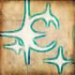 | 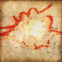 | 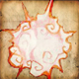
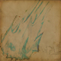 | 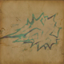 | 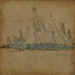 | 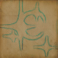 | 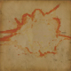 | 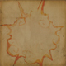

Additional Spell Icons
- Full Heal
- Poison Nullify
- Buff Armor
- Break Armor
- Buff Weapon Break Weapon
- Slow
- Haste

Controls
[W] [A] [S] [D] are bound for movement in the cardinal directions, or navigation of menus
[Space] attacks with the current weapon
[ENTER] casts the current spell
[CTRL] opens a menu to select the current spell from the list of spells
[ESC] enters the main menu

Camera
The camera will be fixed relative to the player at a comfortable viewing angle.

